Alexander County Economic Development Corporation
Business Boost Grant Application

Alexander County Economic Development Corporation (ACEDC) has received a Duke Energy Foundation Grant with the intention of providing one-time Business Boost grants to businesses physically located in Alexander County. The grant program will assist small businesses which were created just before or during the Covid-19 pandemic. The grant program is intended to help new businesses thrive and to encourage additional entrepreneurial efforts in the community.

Purpose: Business Boost awards are project-based and intended to help small businesses which were created after January 1, 2018. Eligible grant projects should focus on at least one of the following areas:

- Modifying physical space
- Improving an e-commerce site for online sales or building e-commerce platforms
- Expanding capacity for delivering goods and services
- Purchase of business equipment
- Accessibility compliance
- Materials for construction
- Additional fixtures required for compliance with public health issues
- Other equipment or tools needed for creative adaptation and customer support

Eligibility: The minimum requirements are as follows:

- The applicant must own and operate a legal business located within Alexander County, NC. Home-based businesses are not eligible.
- Applicant company must have 50 or fewer employees.
- Applicant company must have project investment equal to or exceeding grant award
- All projects must comply with the North Carolina Building Code.
- Grants may not be used for the refinancing of existing debt.
- Applicant companies must have been opened to the public on or after January 1, 2018.
- Project eligibility period is Jan 1, 2023, through June 1, 2023.

Terms: The program offers matching grants subject to the following conditions:

- Grants will be paid on a reimbursement basis.
- Payments will be issued upon submission of contractor or vendor invoices AND proof of payment.
- Projects must be completed, including submission of invoices and proof of payment before June 1, 2023.

Application Deadline: Applications must be received no later than 12:00 noon on January 16, 2023.

Maximum Grant: The maximum amount granted to an individual small business under this program shall be $2,000. Maximum amounts are not guaranteed. The minimum grant amount shall be $500. Final grant amounts will be based on the quality of the application and the number of applicants. The total amount awarded for all grants in this program shall not exceed $7,000.

Awarding of Grants: All applications will be reviewed, approved, and/or denied by the Board of Directors of the Alexander County Economic Development Corporation. Awards will be announced January 31, 2023.

Alexander County Economic Development Corporation
Business Boost Grant Application

Name of Business________________________________________________________

Address_________________________________________________________________

Phone____________________________ Contact Name__________________________

Grant Amount Requested____________________________________________________

Documents required with application:

Please attach a letter on company letterhead which addresses items 1-4 below:

1) Description of the business

2) Date business was founded

3) Description of project with any required permit documentation

4) Amount of expected investment by the business

5) Please also attach project cost estimates on contractor or vendor letterhead.

___________________________
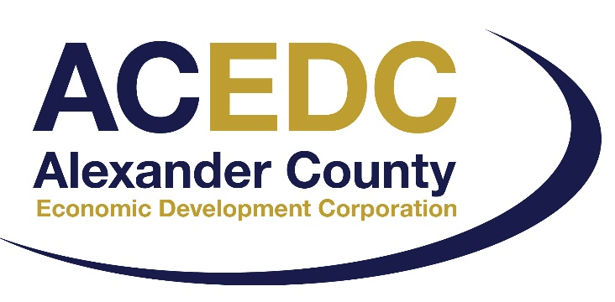
Signature

____________________________
Print Name

____________________________
Title

____________________________
Date

Applications may be returned to Alexander County Economic Development Corporation, 621 Liledoun Road, Taylorsville, NC 28681. Applications may also be returned by email to: ckincaid@alexandercountync.gov. Questions may be addressed to Connie Kincaid at 828-352-7757.

